**TEXTOS / LAY-OUTS – DECLINAISON**

**Tres secciones :**

Who we are

What we do

Contact

**PAGINA 1**

DECLINAISON (DECLENSION in English) is the inflection of nouns/adjectives and articles to indicate number, case and gender, applying in many languages (Arabic, English, French, Spanish …).

FOR US it is the perfect illustration that for ages, men all over the world have understood that, to generate brilliant concepts, all must be tight together…

CONSULTING: You have an idea, a project and you need a fresh pair of eyes to help you identify the idea´s potential and the possible roadblock. Reach out and we will help you…

ENTREPRENEURSHIP: Because we also have our own ideas, we design, plan and execute… Sometimes for 6 months, a year or more…

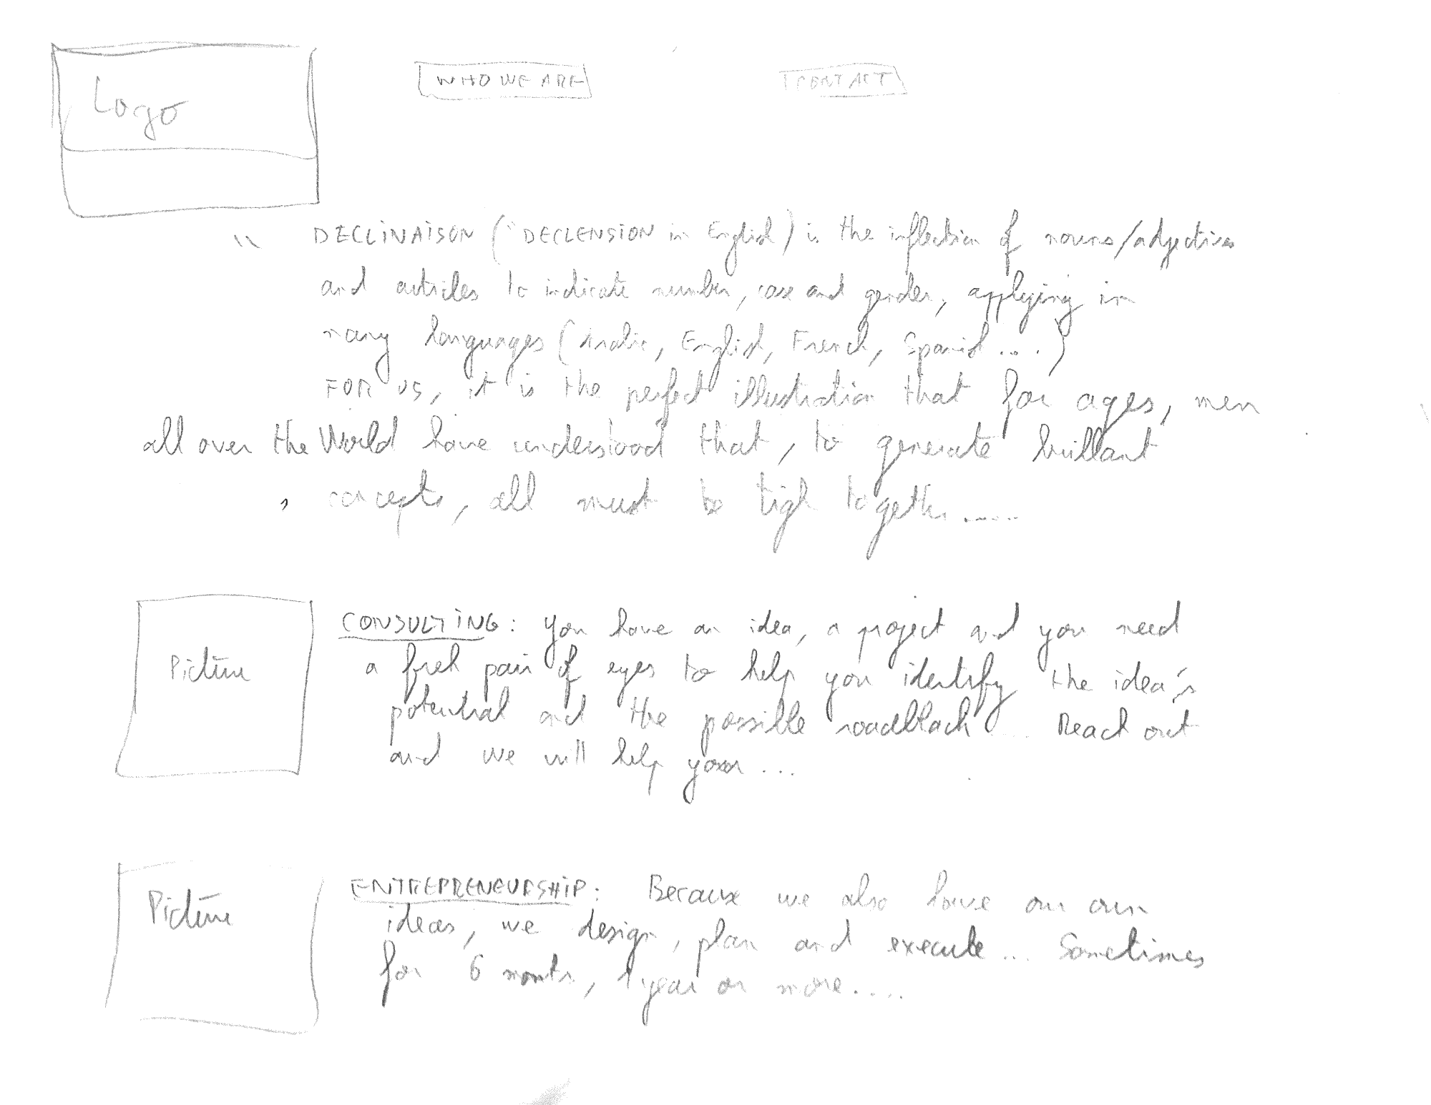

**PAGINA 2**

CONSULTING

Designed for small and medium-sized companies

We can help you for :

* Corporate Development (How could you grow your business ?)
* Inorganic growth (Could you buy a competitor or a business partner ?)
* Due diligence (How much should you offer for a company acquisition?)
* Profitability improvement ( How could you increase your net gain from a given base of revenue?)
* Corporate governance (What rules should you set up for your company daily’s activities and decision making process?)

ENTREPRENEURSHIP

